LAB 7
GROUP BY & HAVING

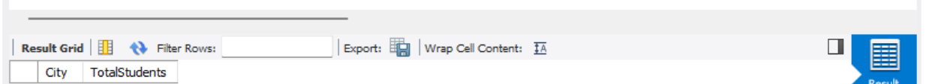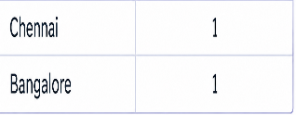

This query groups students by city and counts the number of students in each city. The GROUP BY clause groups students based on their city, and the HAVING clause displays only cities with more than one student.

